Name: Fapohunda Oluwatomi Oche
Matric No: 15/ENG04/025
Title: An Explicit Reference Governor Scheme for Closed-Loop Anesthesia
Authors and Their Affiliations: Mehdi Hosseinzadeh, Member, IEEE, Klaske van Heusden, Guy A. Dumont, Life Fellow, IEEE, and Emanuele Garone, Member, IEEE

Structure
- Abstract
- Introduction
- Modelling of the system
- Fig. 1. PKPD model block diagram
- Control architecture
- Pre-stabilizing the Propofol Delivery System
- Fig. 2. The iControl closed-loop anesthesia system
- Fig. 3. Block diagram of the propofol control system.
- Enforcing Constraints Handling Capability
- Fig. 4. Approximation error for different hypnosis levels.
- Results and Discussion
- Fig. 5. The unconstrained simulated responses of the 44 patients
- Table I Comparison of The Obtained Induction Time.
- Conclusion
- Fig. 6. The simulated responses of the 44 patients with the ERG scheme.
- References
Acronyms
- ECC - European Control Conference
- IEEE – Institute of Electrical and Electronics Engineers
- FIRS MIS - Fonds de la Recherche Scientifique Mandat d’impulsion scientific (Incentive grant for scientific research)
- SAAS - Service d’Automatique et d’Analyse des Syst`emes
- ULB - Universit´e Libre de Bruxelles
- UBC – University of British Columbia
- ERG - Explicit Reference Governor
- PK – PharmacoKinetic model
- PD - PharmacoDynamic model
- DOH – Depth of Hypnosis
- TIVA - Total intravenous anesthesia
- PID - proportional–integral–derivative
- LBM - Lean Body Mass
- DSM - Dynamic Safety Margin
- NF - Navigation Field
- KF - Kalman Filter

Remarks
- By defining approximation error as e(t) = y(t)− ˆy(t), the value of δ₀ can be determined as δ₀ = max_{v2[0,0.5]}sup|(e)t|
- Since the states of the system are not directly measured during the experiments, to determine the Lyapunov function Vi(·), i = 1, · · · ,7 an estimator is needed.
- To make sure that obtained matrix Pi through (31) is valid Lyapunov matrix for all patients, one possible way is to use Kharitonov theory, and replace the constraint ATPi+PiA _ 0 with the resulting four Kharitonov’s based constraints.

Abstract Summary
A closed form control scheme is an improved method for the control of the depth of hypnosis.

Introduction Summary
- Current method of administering anaesthesia dosage is manual feedback control. Closed loop anaesthesia has gained much attention in recent years.
- Anaesthesia consists of three components. Manipulating infusion rate of propofol to control DOH is proposed.
- Propofol hypnosis can be divided into three temporal phases. The main challenge is to administer the drug without overdosing them.
- The need to use constrained control schemes in closed-loop anesthesia to prevent patient’s overdosing has been highlighted.
- The paper makes use of the recently introduced Explicit Reference Governor (ERG) framework.
- Organisation of the paper: model description, proposed ERG scheme details, simulations and conclusion

Comparison between Figure 5 and 6

Figure 5 | Figure 6
The DOH percentage drops from 100% to below 40% in the first 10 minutes | The DOH percentage drops from 100% to above 40% in the first 10 minutes and experiences a steady rise.
The I (t) [ml/h] value is above 200 for most patients, reaching 400 in the first 20 minutes | Most patients have an I (t) [ml/h] approximately equal to 200 in the first 10 minutes
In the Cp [ug/m] plot, the transient region lasts for a short period (less than 5 min) | The transient period lasts for about 10 min for most patients.
In the Ce [ug/m] plot, the transient region lasts for a time approximately less than 5 min. | The transient period lasts for about 10 min.

Key Results
The proposed ERG scheme guarantees constraints satisfaction
• A DOH of 50 % was achieved for all patients
• The ERG scheme automatically converges to the desired level of hypnosis using the auxiliary reference.
• The ERG scheme leads to slower induction for patients.

Conclusion
I see the organization of the ‘conclusion’ section
Yes, I understand the conclusion

Section II
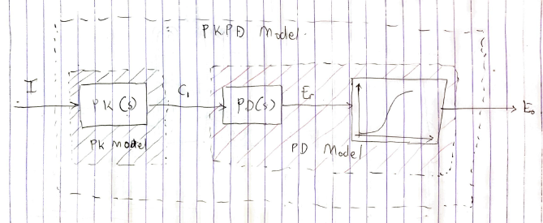

PK model: It shows the relationship between the drug plasma concentration with the administered dose. It considers three compartments: plasma compartment, shallow peripheral compartment and the deep peripheral compartment. Input variable: I (t) (in [mg/s]) is the infusion rate and output variable C1 (in [mg/l]) is the propofol concentration.

PD model: It shows the relationship between the plasma concentration with the pharmacological end-effect. Input variable C1 is the propofol concentration and output variable Eo (t) is the clinical hypnotic effect.

PKPD model: It gives a drug-response relationship of the propofol. Input variable: I (t) (in [mg/s]) is the infusion rate and output variable Eo (t) is the clinical hypnotic effect. The PK model is expressed using the state-space representation below.

$$\left[\begin{matrix}C_{1} \\ C_{2} \\ C_{3}\end{matrix}\right]=\left|\begin{matrix}-(k_{10}+k_{12}+k_{13}) & k_{12} & k_{13} \\ k_{21} & {-k}_{21} & 0 \\ k_{31} & 0 & {-k}_{31}\end{matrix}\right|\left[\begin{matrix}C_{1} \\ C_{2} \\ C_{3}\end{matrix}\right]+\left[\begin{matrix}\frac{1}{V_{1}} \\ 0 \\ 0\end{matrix}\right]I$$

$$k_{10}= \frac{{Cl}_{1}}{V_{1}},k_{12}= \frac{{Cl}_{2}}{V_{1}},k_{21}= \frac{{Cl}_{2}}{V_{2}},k_{13}= \frac{{Cl}_{3}}{V_{1}},k_{31}= \frac{{Cl}_{3}}{V_{3}}$$

C₁, C₂ and C₃ are the propofol concentration in the plasma, fast peripheral compartment, and slow peripheral compartments respectively. 𝑉₁, 𝑉₂ and 𝑉₃ are the volumes for each compartment respectively. Cl₁ is the elimination clearance Cl₂ and Cl₃ are inter-compartmental clearance respectively.

The PD model is expressed as $PD\left(s\right)= \frac{C_{e}(s)}{C_{p}(s)}= e^{-T_{d}\left(s\right).\frac{k_{d}}{s+ k_{d}}}$
$C_{p}\left(t\right)= C_{1}\left(t\right)=1,$ Td (in [s]) and kd (in [s−1]) are transport delay and rate of propofol distribution between the plasma concentration and the brain.

SECTION III
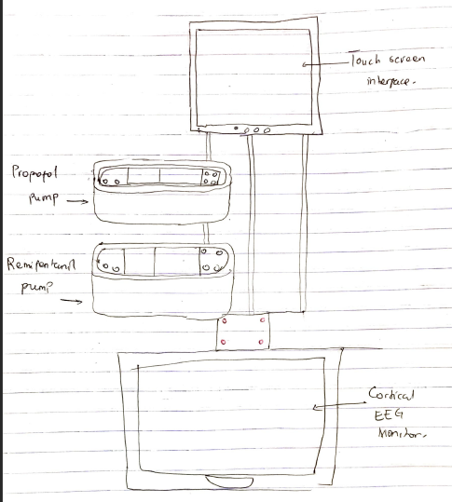
I have read the PID section of the Experience Controls application.

$$G_{ff}\left(s\right)=k+ \frac{k_{i}}{s}$$
$$G_{c}\left(s\right)= \frac{k_{d}N_{s}}{s+N}$$
$$LBM=0.3281×W+0.33929×H-29.5336$$
Using W=71 kg H=173 cm for male

$$LBM=52.4587$$

$$k=0.0243×LBM, k_{i}=0.000165×LBM, k_{d}=1.35×LBM$$

$$k=1.2747, k_{i}=8.6557×{10}^{-3}, k_{d}=70.8192$$

• The iControl system is used for the clinical evaluation of the controller design. It stabilizes the propofol delivery system using a robust PID controller.
• Integrator windup occurs due to the saturation of an actuator in a system leading to large overshoots in the output response (overdose as used in the paper)
• Equation [13] represents a non-linear system
• Constraint satisfaction prevents overdose.
• The aim of the ERG is to determine an invariant set that would contain the state trajectory if the currently auxiliary reference were to remain constant.
• The ERG generates signal which is the input or reference signal to the system and is independent of the propofol delivery system.

